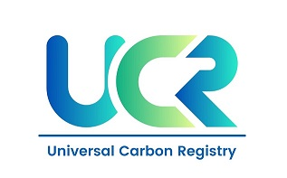
PROJECT CONCEPT NOTE
CARBON OFFSET UNIT (CoU) PROJECT

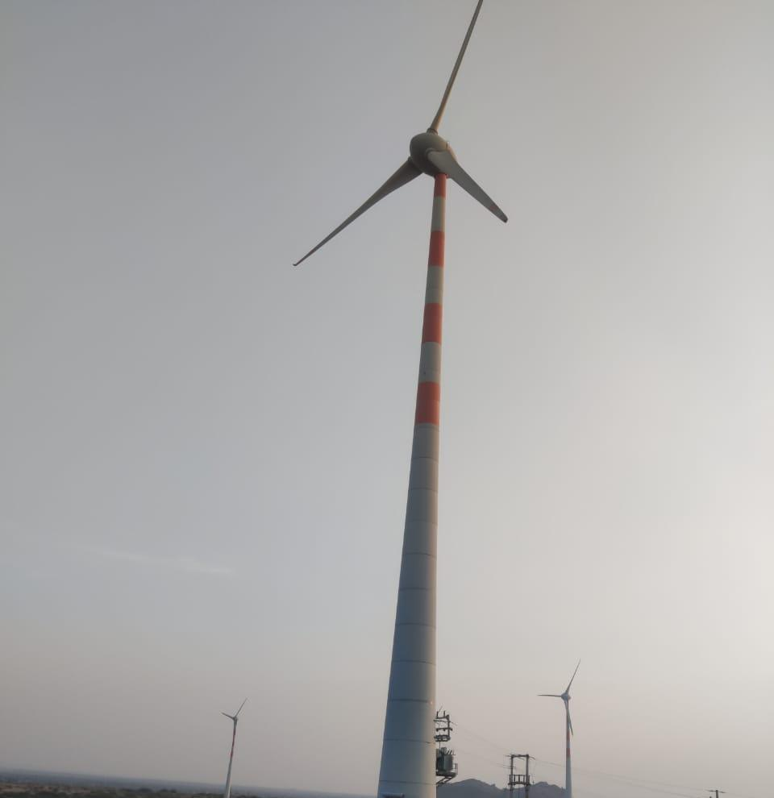

Title: Renewable Energy Wind Power Project in
Rajasthan
Version 2.0
Date 18/03/2024
First CoU Issuance Period:2 years ,10 Months
Date:01/03/2022 to 31/12/2024

Project Concept Note (PCN)
CARBON OFFSET UNIT (CoU) PROJECT
BASIC INFORMATION
Title of the project activity | Renewable Energy Wind Power Project in  Rajasthan
The scale of the project activity | Large-Scale Wind Project
Completion date of the PCN | 18/03/2024
Project participants | Vish Wind Infrastructure LLP  (Private entity)
Host Party | INDIA
Applied methodologies and standardized baselines | ACM0002-Consolidated baseline methodology for grid-connected electricity generation from renewable sources -Version 22.0
Sectoral scopes | 01 Energy industries (Renewable/Non-renewable Sources)
Estimated amount of total GHG emission reductions | 37,283 CoUs (Annually)

SECTION A. Description of project activity

A.1. Purpose and general description of Carbon offset Unit (CoU) project activity >>

The project “Renewable Energy Wind Power Project in Rajasthan” in Jaisalmer & Jodhpur respectively, in the state of rajastan in India. The project consists of 37 machines of Wind World (name of Enercon (India) Ltd. has been changed to Wind World (India) Ltd. effective from 01/01/2013, hereafter Enercon will be refereed as Wind World) make E-53 type WEGs of 800KW capacity each. make E-53 type Wind Energy Converters (WECs) each of capacity 800 KW.

Purpose of the project activity:

The project consists of 37 machines of Wind World (The name of Enercon (India) Ltd. has been changed to Wind World (India) Ltd. From 01/01/2013, hereafter it will be referred as Wind World (India) Ltd.) make E-53 type WEGs of 800KW capacity each totaling to the capacity of 29.6 MW. The WEGs generates 3-phase power at 400V, which is stepped up to 33 kV and further transmitted to Wind World Sub-station. From Wind World substation electricity is further evacuated to the Rajasthan regional electricity grid which is part of the INDIAN (Northern, Eastern, Western and North Eastern) grid (now merged in the integrated Indian grid) in India. The clean and green electricity supplied by the project is contributing towards sustainable growth in the region. Vish Wind Infrastrukture LLP (hereafter referred as ‘VWIL’) is the project owner and project participant for the project activity.

The purpose of the project activity is to utilize renewable wind energy for generation of electricity. The project activity replaces anthropogenic emissions of greenhouse gases (GHG’s) into the atmosphere, which is estimated to be approximately 37,283 tCO₂e per year, by displacing the equivalent amount of electricity generation through the operation of existing fuel mix in the grid comprising mainly fossil fuel based power plants and future capacity expansions connected to the grid.

The purpose of the project activity is to utilize renewable wind energy for generation of electricity. Project activity is the installation of green field energy production using wind as a source of power generation. In the absence of the project activity the equivalent amount of electricity would have been generated from the connected/ new power plants in the Indian grid, which would have been predominantly based on fossil fuels. Whereas the operation of Wind Energy Generators (WEG’s) is emission free and no emissions occur during the lifetime of the project activity.
The first machine under the project activity was commissioned on 23/09/2010 and last machine under the project activity was commissioned on 26/01/2011. The expected operational lifetime of the project is for 20 years. The end date of crediting period is 27/02/2022.
The commissioning dates for all the machines include in the project activity are given in the table below:

S.No | Village | Dist. | No. of Loc. | Loc. No. | No. of WEGs | Date of Comm.
1 | Ugawa | Jaisalmer  Jaisalmer  Jaisalmer  Jaisalmer | 1  1  1  1 | 41  39  38  37 | 4 | 23/09/2010
 |  |  |  |  |  | 23/09/2010
 |  |  |  |  |  | 23/09/2010
 |  |  |  |  |  | 23/09/2010
2 | Ugawa | Jaisalmer  Jaisalmer  Jaisalmer  Jaisalmer  Jaisalmer  Jaisalmer | 1  1  1  1  1  1 | 36  35  34  33  31  30 | 6 | 23/09/2010
 |  |  |  |  |  | 23/09/2010
 |  |  |  |  |  | 23/09/2010
 |  |  |  |  |  | 23/09/2010
 |  |  |  |  |  | 23/09/2010
 |  |  |  |  |  | 23/09/2010
3 | Korwa | Jaisalmer  Jaisalmer | 1  1 | 50  53 | 2 | 23/09/2010
 |  |  |  |  |  | 23/09/2010
4 | Kita | Jaisalmer  Jaisalmer  Jaisalmer  Jaisalmer  Jaisalmer | 1  1  1  1  1 | 121  582  601  602  603 | 5 | 30/09/2010
 |  |  |  |  |  | 30/09/2010
 |  |  |  |  |  | 30/09/2010
 |  |  |  |  |  | 30/09/2010
 |  |  |  |  |  | 30/09/2010
5 | Jelu | Jodhpur  Jodhpur  Jodhpur  Jodhpur  Jodhpur  Jodhpur  Jodhpur  Jodhpur  Jodhpur  Jodhpur  Jodhpur  Jodhpur  Jodhpur  Jodhpur  Jodhpur  Jodhpur | 1  1  1  1  1  1  1  1  1  1  1  1  1  1  1  1 | 153  154  155  156  157  158  159  161  162  163  164  165  166  167  168  169 | 20 | 30/09/2010
 |  |  |  |  |  | 30/09/2010
 |  |  |  |  |  | 30/09/2010
 |  |  |  |  |  | 30/09/2010
 |  |  |  |  |  | 30/09/2010
 |  |  |  |  |  | 30/09/2010
 |  |  |  |  |  | 30/09/2010
 |  |  |  |  |  | 30/09/2010
 |  |  |  |  |  | 30/09/2010
 |  |  |  |  |  | 30/09/2010
 |  |  |  |  |  | 30/09/2010
 |  |  |  |  |  | 30/09/2010
 |  |  |  |  |  | 30/09/2010
 |  |  |  |  |  | 30/09/2010
 |  |  |  |  |  | 17/11/2010
 |  |  |  |  |  | 17/11/2010
5 | Salodi | Jodhpur  Jodhpur  Jodhpur  Jodhpur | 1  1  1  1 | 10  11  509  510 | 20 | 26/01/2011
 |  |  |  |  |  | 26/01/2011
 |  |  |  |  |  | 26/01/2011
 |  |  |  |  |  | 26/01/2011
 |  |  | Total |  | 37

A.2 Do no harm or Impact test of the project activity>>

There are social, environmental, economic and technological benefits which contribute to sustainable development.

- Social benefits:
- The project activity will contribute to socio-economic development through improving the infrastructure for road network and other mode of communications in the remote part of the state during both the construction and operational period.
- The project activity will utilize renewable energy source for electricity generation instead of fossil fuel based electricity generation which would have emitted gaseous, liquid and/or solid effluents/wastes. Thus, the project causes no negative impact on the surrounding environment and contributes to environmental well-being.
- The project activity will contribute towards reduction of the GHG emissions as well as emission of pollutants like SOx, Suspended Particulate Matters (SPMs) etc. by avoiding equivalent amount of power generation from fossil fuel based power plants.

- Environmental benefits:

- Utilizing wind energy instead of burning fossil fuels for electricity generation significantly decreases the emission of harmful pollutants, fostering cleaner air, water, and soil.
- Leveraging wind energy aids in preserving natural resources and minimizing detrimental impacts on the environment, contributing to overall ecological well-being.
- Moreover, harnessing wind energy offers a sustainable alternative to burning fossil fuels, which not only mitigates pollution but also conserves natural habitats and biodiversity, supporting healthier ecosystems and enhancing environmental resilience.

- Economic benefits:
- The project will generate electricity utilizing renewable source like wind, thus will increase the contribution of renewable based power generation in the region and will also help in reducing the demand - supply gap of the respective grid.
- The project activity involves substantial amount of investment, thus will contribute towards generation of direct and indirect employment opportunities as per the requirement of the skilled and semi-skilled manpower.
- Use of a renewable source of energy reduces the dependence on imported fossil fuels and associated price variation, thereby leading to increased energy security.

Goal 7  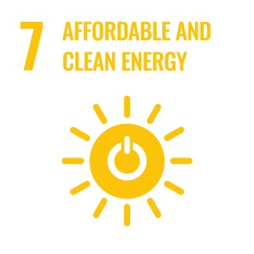 |  | The project activity will generate clean energy, which with increased shared will increase the affordability at a cheaper rate to end user. The project activity will utilize wind energy (renewal resource) to generate power. The project activity will increase the share of renewable resource-based electricity to global mix of energy consumption
Goal 8  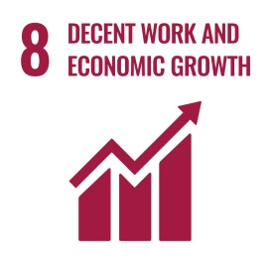 |  | Decent work and economic growth. This project activity generates additional employment for skilled and unskilled, also the project situated in remote area will provide employment opportunities to unskilled people from villages. The training on various aspect including safety, operational issues and developing skill set will also be provided to employees  This project will achieve full and productive employment and decent work.
Goal 13 |  | This 29.6MW wind power project meet the SDG 13 goal by saving fossil fuel and produce clean energy. This project is expected to reduce 37,283 tCO₂ anually
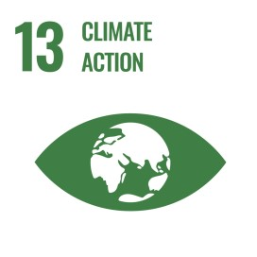 |  | In a Greenfield project, electricity delivered to the grid by the project would have otherwise been generated by the operation of grid connected power plants. Thereby the project activity reduces the dependence on fossil fuel-based generation units and as there are no associated emissions with this project it contributes to the reduction of greenhouse gases (GHG) emissions.

A.3. Location of project activity >>

Country: India
District: Jaisalmer & Jodhpur
Village: Ugawa, Korwa & Kita
State: Rajastan

The Project is located in Jaisalmer & Jodhpur district in the Indian State of Rajasthan. The Project is spread across Ugawa, Korwa & Kita villages of Jaisalmer District and Salodi & Jelu Villages of Jodhpur district in the Rajasthan state of India. The nearest railway station for project activity located at Ugawa, Korwa & Kita villages (District Jaisalmer) is Jaisalmer approximately at a distance of 50 Kms from site, while the nearest railway station for project activity located at Salodi & Jelu villages (DistrictJodhpur) is Jodhpur approximately at a distance of 50 Kms.

Individual WEG location numbers and coordinates are detailed out in below table:-

S.No. | WEG Loc No. | Village | District | State | Latitude | Longitude
1 | 41 | Ugawa | Jaisalmer | Rajasthan | N 26º 37’51.5” | E 70º 57’51.2”
2 | 39 | Ugawa | Jaisalmer | Rajasthan | N 26º 37’41.5” | E 70º 57’33.5”
3 | 38 | Ugawa | Jaisalmer | Rajasthan | N 26º 37’35.4” | E 70º 57’38.7”
4 | 37 | Ugawa | Jaisalmer | Rajasthan | N 26º 37’33.3” | E 70º 57’45.8”
5 | 36 | Ugawa | Jaisalmer | Rajasthan | N 26º 37’27.8” | E 70º 57’49.9”
6 | 35 | Ugawa | Jaisalmer | Rajasthan | N 26º 37’21.6” | E 70º 57’53.9”
7 | 34 | Ugawa | Jaisalmer | Rajasthan | N 26º 37’17.7” | E 70º 57’59.2”
8 | 33 | Ugawa | Jaisalmer | Rajasthan | N 26º 37’14.6” | E 70º 58’05.7”
9 | 31 | Ugawa | Jaisalmer | Rajasthan | N 26º 37’11.3” | E 70º 58’13.3”
10 | 30 | Ugawa | Jaisalmer | Rajasthan | N 26º 37’01.5” | E 70º 58’13.1”
11 | 50 | Korwa | Jaisalmer | Rajasthan | N 26º 37’47.9” | E 70º 56’27.3”
12 | 53 | Korwa | Jaisalmer | Rajasthan | N 26º 38’06.1” | E 70º 56’13.0”
13 | 121 | Kita | Jaisalmer | Rajasthan | N 26º 41’05.2” | E 71º 00’07.2”
14 | 582 | Kita | Jaisalmer | Rajasthan | N 26º 41’58.8” | E 71º 01’44.9”
15 | 601 | Kita | Jaisalmer | Rajasthan | N 26º 40’24.0” | E 71º 04’28.4”
16 | 602 | Kita | Jaisalmer | Rajasthan | N 26º 40’12.2” | E 71º 04’31.5”
17 | 603 | Kita | Jaisalmer | Rajasthan | N 26º 40’08.5” | E 71º 04’19.3”
18 | 153 | Jelu | Jodhpur | Rajasthan | N 26º 31’22.3” | E 72º 46’00.2”
19 | 154 | Jelu | Jodhpur | Rajasthan | N 26º 31’24.2” | E 72º 45’52.0”
20 | 155 | Jelu | Jodhpur | Rajasthan | N 26º 31’31.9” | E 72º 45’46.5”
21 | 156 | Jelu | Jodhpur | Rajasthan | N 26º 31’44.0” | E 72º 45’39.4”
22 | 157 | Jelu | Jodhpur | Rajasthan | N 26º 31’49.0’ | E 72º 45’33.5”
23 | 158 | Jelu | Jodhpur | Rajasthan | N 26º 31’50.8” | E 72º 45’25.1”
24 | 159 | Jelu | Jodhpur | Rajasthan | N 26º 31’55.7” | E 72º 45’17.0”
25 | 161 | Jelu | Jodhpur | Rajasthan | N 26º 31’22.1” | E 72º 45’03.8”
26 | 162 | Jelu | Jodhpur | Rajasthan | N 26º 31’26.4” | E 72º 45’15.8”
27 | 163 | Jelu | Jodhpur | Rajasthan | N 26º 31’19.3” | E 72º 45’24.0”
28 | 164 | Jelu | Jodhpur | Rajasthan | N 26º 31’15.2” | E 72º 45’11.9”
29 | 165 | Jelu | Jodhpur | Rajasthan | N 26º 30’49.8” | E 72º 45’18.1”
30 | 166 | Jelu | Jodhpur | Rajasthan | N 26º 30’44.3” | E 72º 45’22.1”
31 | 167 | Jelu | Jodhpur | Rajasthan | N 26º 30’32.8” | E 72º 45’17.4”
32 | 168 | Jelu | Jodhpur | Rajasthan | N 26º 30’36.7” | E 72º 45’40.3”
33 | 169 | Jelu | Jodhpur | Rajasthan | N 26º 30’43.3” | E 72º 45’35.3”
34 | 10 | Salodi | Jodhpur | Rajasthan | N 26 º 25’35.7” | E 72º 48’32.9”
35 | 11 | Salodi | Jodhpur | Rajasthan | N 26 º 25’25.2” | E 72 º 48’35.8”
36 | 509 | Salodi | Jodhpur | Rajasthan | N 26 º 26’51.1” | E 72 º 50’44.5”
37 | 510 | Salodi | Jodhpur | Rajasthan | N 26 º 26’57.7” | E 72 º 50’35.8”

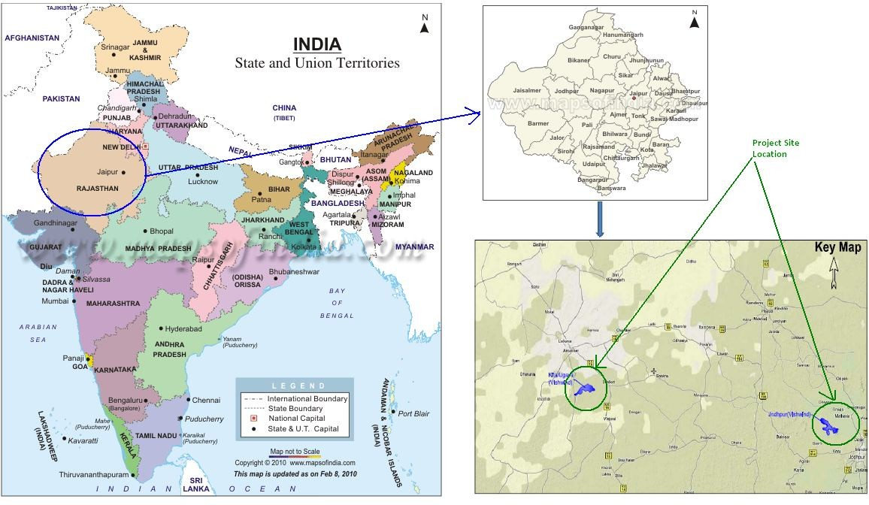

A.4. Technologies/measures >>

The project activity involves 37-wind energy converters (WEGs) of Wind World make (800 KW E-53) with internal electrical lines connecting the project activity with local evacuation facility. The WEGs generate 3-phase power at 400V, which is stepped up to 33 KV. The project activity can operate in the frequency range of 47.5–51.5 Hz and in the voltage range of 400 V ± 12.5%. The average life time of the WEG is around 20 years as per the industry standards. The other salient features of the technology are:

Turbine model | WWIL E- 53
Rated power | 800 KW
Rotor diameter | 53 m
Hub height | 75 m
Turbine Type | Gearless horizontal axis wind turbine with variable rotor speed
Power regulation | Independent electromechanical pitch system for each blade.
Cut in windspeed | 2.5 m/s
Rated wind speed | 12 m/s
Cut out Windspeed | 28-34 m/s
Extreme Wind Speed | 59.5 m/s
Rated rotational speed | 32 rpm
Operating range rot.  speed | 12-29 rpm
Orientation | Upwind
No of Blades | 3
Blade Material | Glass Fiber reinforced Epoxy
Gear box type | Gear less
Generator type | Synchronous generator
Braking | Aerodynamic
Output Voltage | 400 V
Yaw System | Active yawing with 4 electric yaw drives with brake motor and friction bearing
Tower | 74 m concrete

A.5. Parties and project participants >>

Party (Host) | Participants
India (Host) | Vish Wind Infrastructure LLP  (Private entity)

A.6. Baseline Emissions>>

The baseline scenario identified at the PCN stage of the project activity is:

The scenario existing prior to the implementation of the project activity, is electricity delivered to the facility by the project activity that would have otherwise been generated by the operation of grid connected power plants and by the addition of new generation sources. This is a green field project activity. There was no activity at the site of the project participant prior to the implementation of this project activity. Hence pre-project scenario and baseline scenario are the same.

As per the approved consolidated methodology ACM0002 Version 22, if the project activity is the installation of a new grid-connected renewable power plant/unit, the baseline scenario is the following: “If the project activity is the installation of a Greenfield power plant, the baseline scenario is electricity delivered to the grid by the project activity would have otherwise been generated by the operation of grid-connected power plants and by the addition of new generation sources to the grid”.

The Schematic diagram showing the baseline scenario:

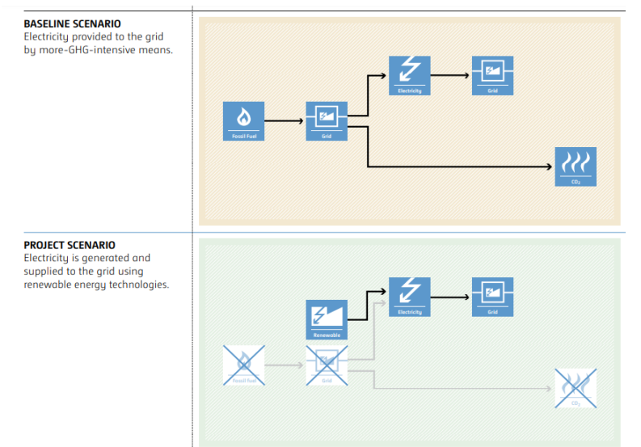
A.7. Debundling>>
This Project is not a debundled component of a larger project activity.

SECTION B. Application of methodologies and standardized baselines

B.1. References to methodologies and standardized baselines >>

SECTORAL SCOPE –01 Energy industries (Renewable/Non-renewable sources)

TYPE - Renewable Energy Projects

CATEGORY- ACM0002., Consolidated baseline methodology for grid-connected electricity generation from renewable sources -Version 22.0

B.2. Applicability of methodologies and standardized baselines >>

Applicability Criteria. | Applicability status
1)This methodology is applicable to grid-connected renewable energy power generation project activities that:  (a) Install a Greenfield power plant;  (b) Involve a capacity addition to (an) existing plant(s);  (c) Involve a retrofit of (an) existing operating plant(s)/unit(s);  (d) Involve a rehabilitation of (an) existing plant(s)/unit(s), or  (e) Involve a replacement of (an) existing plant(s)/unit(s).  (f) Install a Greenfield power plant together with a grid-connected Greenfield pumped storage power plant. The greenfield power plant may be directly connected to the PSP or connected to the PSP through the grid. | The proposed project involves establishing a new grid-connected renewable wind power plant, confirming to the specified criteria.
2) In case the project activity involves the integration of a BESS, the methodology is applicable to grid-connected renewable energy power generation project activities that:  (a)Integrate BESS with a Greenfield power plant;  (b) Integrate a BESS together with implementing a capacity addition to (an) existing solar photovoltaic1 or wind power plant(s)/unit(s);  (c) Integrate a BESS to (an) existing solar photovoltaic or wind power plant(s)/unit(s) without implementing any other changes to the existing plant(s);  (d) Integrate a BESS together with implementing a retrofit of (an) existing solar photovoltaic or wind power plant(s)/unit(s).  (e) Integrate a BESS together with a Greenfield power plant that is operating in coordination with a PSP. The BESS is located at site of the greenfield renewable power plant. | The project entails installing a new grid-connected renewable wind power project without the integration of a Battery Energy Storage System (BESS). Therefore, this condition does not apply to the project activity.
3)The methodology is applicable under the following conditions:  (a) Hydro power plant/unit with or without reservoir, wind power plant/unit, geothermal power plant/unit, solar power plant/unit, wave power plant/unit or tidal power plant/unit;  (b) In the case of capacity additions, retrofits, rehabilitations or replacements (except for wind, solar, wave or tidal power capacity addition projects) the existing plant/unit started commercial operation prior to the start of a minimum historical reference period of five years, used for the calculation of baseline emissions and defined in the baseline emission section, and no capacity expansion, retrofit, or rehabilitation of the plant/unit has been undertaken between the start of this minimum historical reference period and the implementation of the project activity;  (c) In case of Greenfield project activities applicable under paragraph 7(a) above, the project participants shall demonstrate that the BESS was an integral part of the design of the renewable energy project activity (e.g., by referring to feasibility studies or investment decision documents);  (d) The BESS should be charged with electricity generated from the associated renewable energy power plant(s). Only during exigencies2 may the BESS be charged with electricity from the grid or a fossil fuel electricity generator. In such cases, the corresponding GHG emissions shall be accounted for as project emissions following the requirements under section 5.4.4 below. The charging using the grid or using fossil fuel electricity generator should not amount to more than 2 per cent of the electricity generated by the project renewable energy plant during a monitoring period. During the time periods (e.g., week(s), months(s)) when the BESS consumes more than 2 per cent of the electricity for charging, the project participant shall not be entitled to issuance of the certified emission reductions for the concerned periods of the monitoring period.  (e) In case the project activity involves PSP, the PSP shall utilize the electricity generated from the renewable energy power plant(s) that is operating in coordination with the PSP during pumping mode | The proposed project involves installing new wind power plants without integrating a Battery Energy Storage System (BESS). Thus, the mentioned criterion does not apply
4)In case of hydro power plants, one of the following conditions shall apply:  a)The project activity is implemented in an existing single or multiple reservoirs, with no change in the volume of any of reservoirs; or  b)The project activity is implemented in an existing single or multiple reservoirs, where the volume of the reservoir(s) is increased and the power density calculated using equation (7) is greater than 4 W/m2; or  c)The project activity results in new single or multiple reservoirs and the power density calculate equation (7), is greater than 4 W/m2.  d)The project activity is an integrated hydro power project involving multiple reservoirs, where the power density of any of the reservoirs, calculated using equation (7), is lower than or equal to 4 W/m2, all of the following conditions shall apply.  (i)The power density calculated using the total installed capacity of the integrated project, as per equation (8), is greater than 4 W/m2;  (ii) Water flow between reservoirs is not used by any other hydropower unit which is not a part of the project activity;  (iii)Installed capacity of the power plant(s) with power density lower than or equal to 4 W/m2 are:  - Lower than or equal to 15 MW; and  - Less than 10 per cent of the total installed capacity of integrated hydro power project. | The proposed project involves the installation of wind power plants/units. Hence, the mentioned criterion is not applicable.
5)In the case of integrated hydro power projects, project proponent shall:  a)Demonstrate that water flow from upstream power plants/units spill directly to the downstream reservoir and that collectively constitute to the generation capacity of the integrated hydro power project; or  b)Provide an analysis of the water balance covering the water fed to power units, with all possible combinations of reservoirs and without the construction of reservoirs. The purpose of water balance is to demonstrate the requirement of specific combination of reservoirs constructed under CDM project activity for the optimization of power output. This demonstration has to be carried out in the specific scenario of water availability indifferent seasons to optimize the water flow at the inlet of power units. Therefore this water balance will take into account seasonal flows from river, tributaries (if any), and rainfall for minimum five years prior to implementation of CDM project activity. | The proposed project activity involves the installation of wind power plants/units. Therefore, the mentioned criteria are not applicable.
6) In the case of PSP, the project participants shall demonstrate in the PDD that the project is not using water which would have been used to generate electricity in the baseline. | The proposed project activity involves installing wind power plants/units. Therefore, the specified criteria are not applicable.
7)The methodology is not applicable to:  a)Project activities that involve switching from fossil fuels to renewable energy sources at the site of the project activity, since in this case the baseline may be the continued use of fossil fuels at the site;  b) Biomass-fired power plants; | The proposed project activity involves installing wind power plants/units. Therefore, the specified criteria are not applicable.
8)In the case of retrofits, rehabilitations, replacements, or capacity additions, this methodology is only applicable if the most plausible baseline scenario, as a result of the identification of baseline scenario, is “the continuation of the current situation, that is to use the power generation equipment that was already in use prior to the implementation of the project activity and undertaking business as usual maintenance | The proposed project activity involves installing wind power plants/units. Therefore, the specified criteria are not applicable.

B.3. Applicability of double counting emission reductions >>

The project activity is registered under Clean Development Mechanism (CDM) project with registration number 5090, as well as Gold Standard (GS) with reference number 5007. The crediting period of this project under CDM & GS is 28/02/2012 to 27/02/2022. PP seeks verification under UCR from 01/03/2022 onwards, i.e., crediting period for UCR starts from 01/03/2022. Hence, there is no double counting for said projects.

B.4. Project boundary, sources and greenhouse gases (GHGs)>>

According to the applicable methodology, spatial extent of this project activity includes the project site and all the power plants connected physically to the electricity system that the power project is connected to. The project activity is connected to the network of state transmission utility which falls in INDIAN grid. Thus the project boundary includes all the power plants physically connected to the INDIAN grid.

Project boundary includes all the 37 WEGs of VWIL along with the other customer WEGs connected to the sub-station. Project boundary includes main and backup meters for energy monitoring. Project activity is connected through total 4 sub-stations (2 EB (Electricity Board) sub-stations & 2 WWIL Pooling substations) as follows:-

1) 16 MW of Project activity installed in Jodhpur District:-

Metering is done at 132 kV billing metering point (one main & one check meter) connected at 132kV EB sub-station (PS-8 Narwa). There is one backup metering point (one main & one check meter) connected at Salodi - 132kV WWIL pooling sub-station. Project activity is connected to WWIL pooling sub-station (132kV, Salodi) through 33 KV line. Further a 132kV transmission line (EHV line) connects the WWIL pooling sub-station to state utility sub-station (132kV, PS-8) where energy monitoring is done.

2) 13.6 MW of Project activity installed in Jaisalmer District:-

Metering is done at 220 kV billing metering point (one main meter) connected at 220kV EB sub-station (Akal. There is one backup metering point (one main meter) connected at Bhu – 220 kV sub-station (WWIL pooling sub-station). Project activity is connected to WWIL pooling sub-station (220kV, Bhu) through 33 KV line. Further a 220kV transmission line (EHV line) connects the WWIL pooling sub-station to state utility sub-station (220kV, Akal) where energy monitoring is done.

From state utility substation (EB Sub-station) electricity is transmitted to India grid though transmission lines. A schematic of project boundary diagram is shown below.

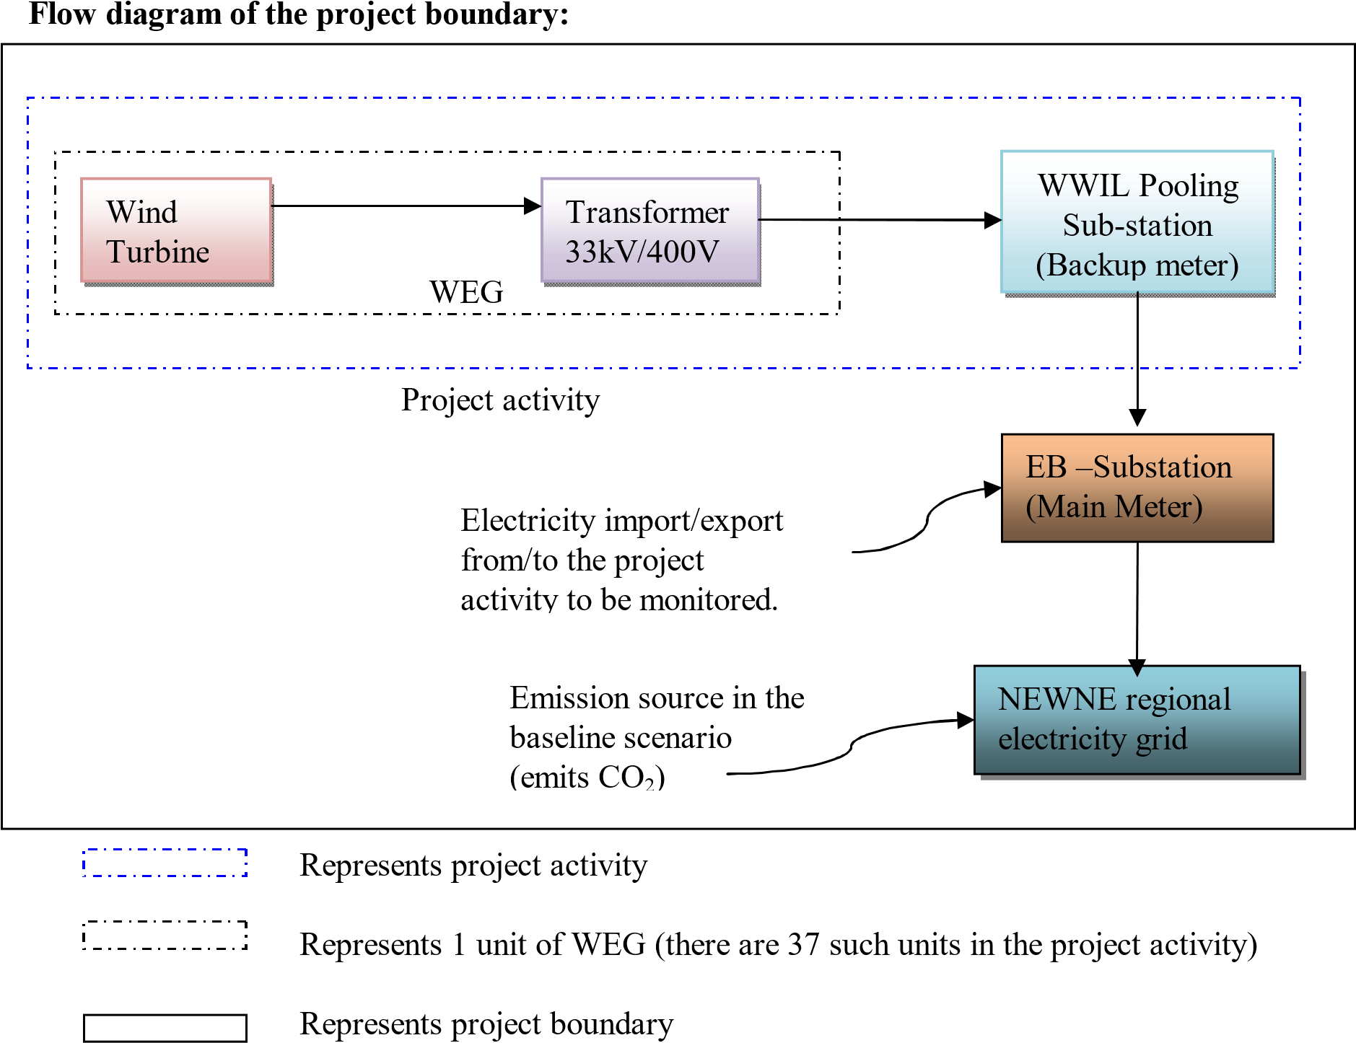

The baseline study of INDIAN grid shows that the main sources of GHG emissions in the baseline are CO₂ emissions from the conventional power generating systems, the other emissions are that of CH₄ and N₂O but both emissions were conservative and are excluded for simplification of the project. The project activity is the emission free electricity generation from renewable sources and hence emits no gases in the atmosphere.

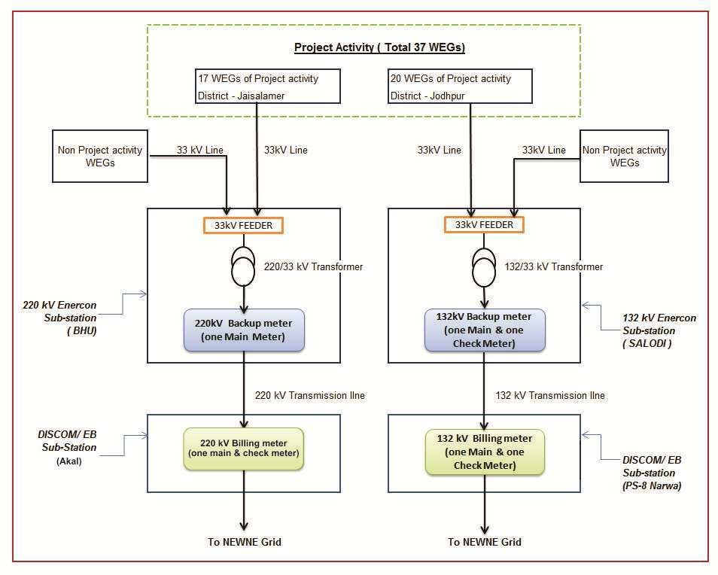

Following table indicates the sources and gases included in the project boundary:
Source |  | GHGs | Included? | Justification/Explanation
Baseline scenario | Grid connected electricity generation | CO₂ | Yes | In the baseline scenario, the electricity would have been sourced from the INDIAN grid which in turn would be connected to fossil fuel fired power plants which emit CO₂.
Baseline scenario | Grid connected electricity generation | CH₄ | No | No methane is expected to be emitted.
Baseline scenario | Grid connected electricity generation | N₂O | No | No nitrous oxide is expected to be emitted.
Project Scenario | Greenfield wind  energy  conversion system | CO₂ | No | The project activity does not emit any emissions.
Project Scenario | Greenfield wind  energy  conversion system | CH₄ | No | No methane is expected to be emitted.
Project Scenario | Greenfield wind  energy  conversion system | N₂O | No | No nitrous oxide is expected to be emitted.

B.5. Establishment and description of baseline scenario >>

As per the approved consolidated methodology ACM0002. version - 22, if the project activity is the installation of a new grid-connected renewable power plant/unit, the baseline scenario is the following:

“The baseline scenario is that the electricity delivered to the grid by the project activity would have otherwise, been generated by the operation of grid-connected power plants and by the addition of new generation sources into the grid”

The project activity involves setting up of a new grid connected wind power plant to harness the green power from wind energy. In the absence of the project activity, the equivalent amount of power would have been supplied by the Indian grid, which is fed mainly by fossil fuel fired plants. The power produced at grid from the other conventional sources which are predominantly fossil fuel based. Hence, the baseline for the project activity is the equivalent amount of power produced at the Indian grid.

As per approved consolidated methodology ACM0002, version 22.0, emission reduction is estimated as difference between the baseline emission and project emission after factoring into leakage

Emission reductions are calculated as per methodology ACM0002, Version 22.0 Equation 17 :

𝐸𝑅y= 𝐵𝐸y− 𝑃𝐸y (Eq. 1)

Where,
𝐸𝑅y = Emissions reductions in year y (t CO2)
𝐵𝐸y = Baseline emissions in year y (t CO2)
𝑃𝐸y = Project emissions in year y (t CO2)

Baseline Emissions

The baseline emissions as per methodology ACM0002, Version 22.0, para 57 ; encompass solely the CO2 emissions stemming from electricity generation in power plants displaced by the project activity. The methodology operates on the assumption that any electricity generation exceeding baseline levels would have originated from established grid-connected power plants and the integration of new grid-connected power plants.

The Baseline emissions as per methodology ACM0002, Version 22.0 Equation 11 in year y can be calculated as follows:

BE y = EG PJ, y * EF grid, CM, y

Where:

BE_{y}= Baseline emissions in year y (tCO₂/yr)

EG_{PJ,y}= Quantity of net electricity generation that is produced and fed into the grid as a result of the implementation of the project activity in year y (MWh/yr)

EF_{grid,CM,y}= Combined margin CO₂ emission factor for grid connected power generation in year y calculated using the latest version of the “Tool to calculate the emission factor for an electricity system”, version 02.2.1 (tCO₂/MWh)

Since the project activity is the installation of a new grid connected renewable power plant (green field project), hence, EG_{PJ,y} has been calculated as :

EGPJ,y = EGfacility,y

Where:
EG_{PJ,y} | = Quantity of net electricity generation that is produced and fed into the grid as a result of the implementation of the project activity in year y (MWh/yr)
EGfacility,y | = Quantity of net electricity generation supplied by the project plant/unit to the grid in year y (MWh/yr)

A "grid emission factor" denotes the CO2 emission factor (measured in tCO2/MWh) associated with each unit of electricity supplied by an electricity system. The UCR suggests employing an emission factor of 0.9 from 2013 to 2023 and Emission Factor 0.757 tCO2/MWh and as a cautious estimate for Indian projects not previously verified under any GHG program. Similarly, for the vintage 2021-22, the combined margin emission factor obtained from the CEA database in India corresponds with the default value. Consequently, the same emission factor is utilized for computing emission reductions.
Regarding project emissions, ACM0002 version 22.0 specifies that only emissions related to fossil fuel combustion, emissions from the operation of geothermal power plants due to the release of non-condensable gases, and emissions from water reservoirs of hydroelectric plants should be taken into account. Since the project involves a wind power project, emissions from renewable energy plants are negligible
Hence (PEy = 0).

Leakage Emission:
Leakage, as outlined in ACM0002 version 22.0, para 5.6, is considered to be zero as there is no transfer of energy-generating equipment in the project activity
Hence (LEy = 0).

While the actual emission reduction achieved during the initial crediting period will be submitted during the first monitoring and verification, an ex-ante estimation is provided for reference.

Estimated Annual or Total baseline emission reductions (BEy )=37,283 CoUs /year (37,283 tCO_{2eq}/year)

Year | Net Generation | Baseline Emissions | Project  Emissions | Leakage | Emission  Reductions
Year | MWh | (tCO₂e) | (tCO₂e) | (tCO₂e) | (tCO₂e)
Year 1 | 47458.00 | 42712.20 | 0.00 | 0.00 | 42712.20
Year 2 | 47458.00 | 42712.20 | 0.00 | 0.00 | 42712.20
year 3 | 47458.00 | 35925.71 | 0.00 | 0.00 | 35925.71
Year 4 | 47458.00 | 35925.71 | 0.00 | 0.00 | 35925.71
Year 5 | 47458.00 | 35925.71 | 0.00 | 0.00 | 35925.71
Year 6 | 47458.00 | 35925.71 | 0.00 | 0.00 | 35925.71
Year 7 | 47458.00 | 35925.71 | 0.00 | 0.00 | 35925.71
Year 8 | 47458.00 | 35925.71 | 0.00 | 0.00 | 35925.71
Year 9 | 47458.00 | 35925.71 | 0.00 | 0.00 | 35925.71
Year 10 | 47458.00 | 35925.71 | 0.00 | 0.00 | 35925.71
Total Emission reduction | 474580 | 372830 | 0 | 0 | 372830
Average Emission Reduction | 47458 | 37283 | 0 | 0 | 37,283

B.6. Prior History>>

The project activity is registered under Clean Development Mechanism (CDM) project with registration number 5090, as well as Gold Standard (GS) with reference number 5007. The crediting period of this project under CDM & GS was 28/02/2012 to 27/02/2022.

B.7. Changes to start date of crediting period >>

There is no change in the start date of crediting period.

B.8. Permanent changes from PCN monitoring plan, applied methodology or applied standardized baseline >>

There are no permanent changes from registered PCN monitoring plan and applied methodology

B.9. Monitoring period number and duration>>

Crediting Period: 01/03/2022 to 1/12/2030.

First Issuance Period:2 years,10 months – 01/03/2022 to 31/12/2024

B.8. Monitoring plan>>

Data and Parameters available at validation (ex-ante values):

Data/Parameter | EG facitlity,y
Data unit | MWh
Description | Net electricity generation supplied to the grid by the Project activity.
Source of Data | The break-up sheet prepared by EPC contractor based on Joint Meter Reading (JMR)
Measurement methods and procedures | Jodhpur Site:-  - There is a billing metering point (one main & one check meter) located at 132kV Discom’s sub-station at PS-8 Narwa.  - There is also a backup metering (one main & one check meter) located at 132kV WWIL’s sub-station at Salodi.  - All the above meters are 0.2% accuracy class. There are other WEGs apart from the project activity WEGs that are connected to these meters at respective sub-station.  Jaisalmer Site:-  - There is a billing metering point (one main meter) located at 220kV Discom’s sub-station at Akal.  - There is also a backup metering (one main meter) located at 220kV WWIL’s sub-station at BHU  - All the above meters are 0.2% accuracy class. There are other WEGs apart from the project activity WEGs that are connected to these meters at respective sub-station.  Measurement & Recording of electricity:  -Main and Backup meters measures the electricity (export & Import) on continuous basis and recorded by state utility on monthly basis.  -Panel meter (LCS controller) measures the net electricity generation (Gross Export - Gross Import) on continuous basis and daily/monthly data can be sourced/recorded from online SCADA system.  Data Type: Measured  Monitoring equipment: Energy Meters are used for monitoring Archiving Policy: Electronic  Calibration frequency: Once in 5 years (considered as per provision of CEA India). The net electricity generated by the project activity will be calculated
Value Applied | 47,458
Monitoring frequency | Monthly
Purpose of data | For baseline emission calcualtions

Data / Parameter: | 𝐸𝐹Grid,y
Data unit: | tCO2 /MWh
Description: | A "grid emission factor" refers to a CO2 emission factor (tCO2/MWh) which will be associated with each unit of electricity provided by an electricity system. The UCR recommends an emission factor of 0.9 tCO2/MWh for the for the 2013 - 2020 years and 0.757 tCO2/MWh for year 2024 as a fairly conservative estimate for Indian projects not previously verified under any GHG program. Hence, the same emission factor has been considered to calculate the emission reduction under conservative approach.
Source of data: | UCR CoU Standard Update: 2024 Vintage UCR Indian Grid Emission Factor Announced | by Universal Carbon Registry | Jan, 2025 | Medium
Measurement  procedures (if any): | -
Monitoring frequency: | Ex-ante fixed parameter
QA/QC procedures: | For the calculation of Emission Factor of the grid
Any comment:

As per UCR CoU Standard Update: 2024 Vintage UCR Indian Grid Emission Factor Announced | by Universal Carbon Registry | Jan, 2025 | Medium
The connection point of the project activity to a particular substation is decided by state utility and hence, the same might change in future. However the procedure for allocation of apportioning of electricity generated will remain same.
meter_reg.pdf (cea.nic.in)

